**MODELLING OSCILLATIONS**

Task 2a)

i) the first terms are production

ii) the second terms are degradation

iii) in the case that:

* there is no cooperativity in its action (i.e. molecules of S act by themselves) so n=1)
* the level of the activator S is low and much less that K (i.e. far from rate saturation) i.e. S<<K

$$rate \left[P production\right]= V\frac{S^{n}}{K^{n}+S^{n}}≈\frac{V}{K}S=kS for n=1 and S≪K$$

where *k* the rate constant in the simplified expression is equal to *V/K*

iv)a) X activates production of Y ( rate of production is proportional to [X] )

b) Y activates production of Z ( rate of production is proportional to [Y] )

c) Z inhibits production of X ( as there is a maximum rate of X production when Z is absent falling to zero in limit that Z is large. Half maximal rate when Z=KI )

v)

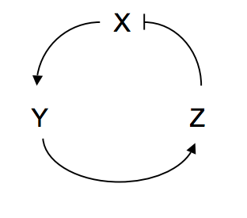

Z inhibits production of X directly – through the 1/(K+Z) factor in its production term.

Given a fixed rate of X production, the concentration of X will increase until the rate of degradation balances production rate. However this isn’t direct inhibition of the production of X, so we do not add ‘self-inhibition’ arrows.

v) Initially there is only production of X, as X builds up it will start production of Y which similarly starts production of Z, which then inhibits production of X.

ii) System reaches steady value after initial transient behaviour (strongly damped oscillations)

iii) Phase diagram should show spiral in this case

Task c) minimum value is n=9

1. run for very long times / show that system returns to cycle after perturbation from it
2. period just under 4

amplitude in X 0.07 to 0.03

Y 0.11 to 0.23

Z 1.35 to 1.95

If we wanted to calculate accurate value from the timeseries we could manually slice the data so it contained a few oscillation periods. We could then use Pythons max and min functions to find the amplitudes.

To find the time period is harder e.g. we could loop over the data looking for a maximum value. At this point we store the time then move to the next maximum. The time between maximum points is the period.

1. oscillations become more like sawtooth than sinewaves. You might also comment that the period becomes longer ~5 units and the amplitude also increases (X and Y have double the amplitude, Z has triple the amplitude compared to n=9).

Task d) min n is now 5

ii) extra species introduces more delay so which enables oscillations with less non-linearity in ODEs